# V2X HUB Signal Cycle Failure Logic

This document outlines the estimation of signal cycle failure for V2X Hub. The signal cycle failure is defined as the occurrence of one or more stopped vehicles that are not served within a signal cycle (NCHRP 2015). This occurrence can be identified for each signal cycle. If needed, a total cycle failure rate can be defined as the percentage of signal cycle failures among all signal cycles in a certain time interval, e.g., a couple of hours that include the morning peak-hour. Further, to help evaluating the signal phasing, the phase(s) in which the cycle failures had happened can be recorded. Given the current length of the queue at each direction and each lane, the signal cycle failure can be identified by detecting whether the back of the queue has reached the stop bar before the signal light turns back to red. If when the signal turns back to red, the queue has not been fully discharged from the intersection during the previous cycle, then a cycle failure is detected for that lane and direction during that signal cycle.

## Requirements and Assumptions

* Connected vehicles are equipped with OBUs.
* Connected vehicles should be able to frequently send BSMs to V2X Hub through an RSU when entered to a certain vicinity of the RSU.
* V2X Hub should be able to frequently receive SPaT messages from the signal controller.

## Inputs to the Signal Cycle Failure Estimation Algorithm

* BSM
  + Vehicle location
  + Vehicle speed
  + Vehicle acceleration
* MAP
  + Roadway geometry
* SPaT
  + Real-time signal statues (i.e., red or green; yellow can be considered as part of the green interval in this logic)
* Parameters
  + RSU detection space range
  + Stopping speed range (~1 m/s)
  + Default backward shock-wave speed 1 (depends on traffic demand, see Figure 2)
  + Default backward shock-wave speed 2 (~ 10.5 m/s, see Figure 2)
  + Start-up lost time (~ 2 s or regional input)
  + Default free-flow speed at the stop bar (depends on the intersection geometry and speed limit)

## Steps to the Signal Cycle Failure Estimation

As the inputs are continuously fed into V2X Hub, the signal cycle failure algorithm below is repeated at every predetermined time interval. Also, these steps are applied to each lane of each direction separately. The algorithm first estimates the location of the back of the queue. Let $t$ and $τ^{sl}$ define the current time and start-up lost time, respectively.

1. Update the list of connected vehicles located in the RSU range.
2. Update vehicle positions, speeds, and accelerations in the list. BSM messages include vehicle positions formatted as GPS coordinates (i.e., latitudes and longitudes). These coordinates should be converted into a longitudinal coordinate system that decreases as the vehicle approach the intersection and the origin of the coordinate system is set to the stop bar location. Each direction can be assigned to one longitudinal coordinate system. Figure 1 illustrates the longitudinal coordinate system along a direction of a roadway.

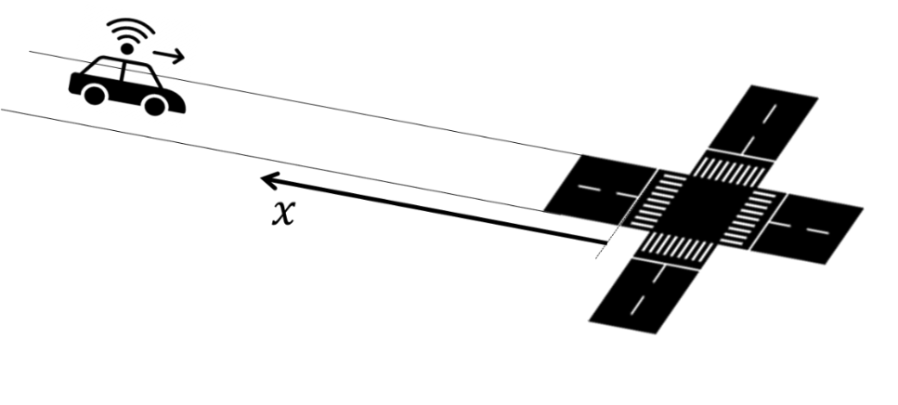

Figure 1 Longitudinal coordinate system (source: FHWA).

1. Sort vehicles according to their distance from the stop bar or their values in the longitudinal coordinate system in ascending order. For system efficiency, V2X Hub may save the order obtained from the previous algorithm iterations, and update that as a vehicle enters the range, change lane, or departs from the intersection.
2. Update vehicle states and the corresponding state change times. For each vehicle in the list, we define two states: moving and stopped. A vehicle is set to the stopping state when its speed drops to a value less than the stopping speed range parameter, and moving state otherwise. Depending on the quality of acceleration profiles provided by the BSM messages, we may be able to use both speed and acceleration characteristics to classify vehicle states. V2X Hub records the vehicle states and the corresponding state change time, defined as stopping and accelerating times and adds them to the list. The accelerating times are only defined when the signal is green and thus the vehicles start accelerating to traverse through the intersection.
3. Update the shockwave speeds. We define two backward shockwaves. The first one separates the change of vehicle states from the moving to stopping states as vehicles approach the intersection. The second one separates the state changes from stopping to moving as vehicles start accelerating when the signal turns green. Figure 2 illustrates the two backward shockwaves in a space-time diagram. This figure shows vehicle trajectories for a stream of vehicles approaching a signalized intersection. The traffic signal status is shown as red, green and yellow bars at the intersection (shown at top of the figure). A portion of vehicles in this figure are connected (OBU-equipped) vehicles, which their trajectories are shown as solid red curves, and the remaining vehicles with dashed-blue trajectories are not connected. The non-connected vehicle trajectories are invisible to the RSU. However, the location of connected vehicles can be broadcasted to the RSU at any time once they are in the RSU detection range. The 4-point orange and 5-point green stars in Figure 2 indicate the stopping and accelerating space-time points, respectively. These points actually separate the vehicle states in the space-time diagram. Connecting the stopping space-time points together yields shockwave 1, as shown as dashed red line. Similarly, we can obtain shockwave 2 by connecting the accelerating space-time points together, shown as dashed green line.

The speeds of these shockwaves, which are the absolute values of the shockwave slopes in the space-time diagram can be determined by fitting a linear regression model to the corresponding points in the space-time diagram, calculated as

$$w_{s}=\frac{I_{s}\left(\sum_{i}{t_{si}p_{si}}\right)-\left(\sum_{i}{t_{si}}\right)\left(\sum_{i}{p_{si}}\right)}{I_{s}\left(\sum_{i}{t_{si}^{2}}\right)-{\left(\sum_{i}{t_{si}}\right)}^{2}},s=1,2,$$

where $w_{s}$ is the shockwave speed $s$, $I_{s}$ is the number of stopping/accelerating points used for estimating the speed of shockwave speed $s$, and $t_{si}$ and $p_{si}$ are the time and location of point $i$ along shockwave speed $s$, $∀i=1,2,…,I_{s},s=1,2$, respectively. Note that in order to estimate the shockwave speeds with the linear regression formula, at least two stopping/accelerating points are required for each of the shockwaves. In case that only one stopping/accelerating point is available for each of the shockwaves, the corresponding shockwave speed(s) is(are) set to the default value(s) defined in the set of parameters. For shockwave 1, different default values can be estimated using offline historical traffic data for different times of a day during weekday, weekend, and special event periods or can be estimated in real-time using the estimated traffic flow. However, shockwave 2 default value can be set to a single static value that depends on the intersection saturation flow rate and jam density, which can be also calibrated using historical traffic data.

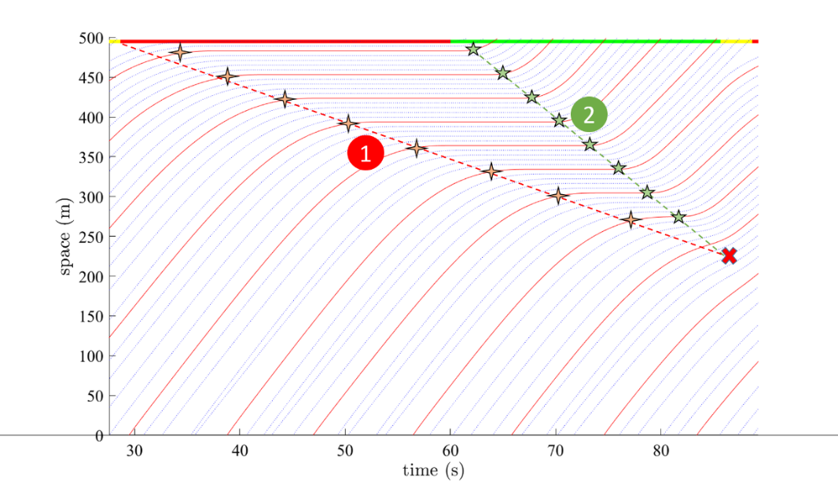

Figure 2 An illustration to backward shockwaves (source: FHWA).

If the signal status is green, then update the queue length upper bound. It can be shown that the queue cannot spill back farer than the intersection between the two shockwaves illustrated as red multiply symbol in Figure 2. This upper bound can be updated once the signal turns into green, and shockwave speeds 1 and 2 are estimated. Let $\overline{Q}$ denote the queue length upper bound that is calculated as follows. Figure 3 illustrates $\overline{Q}$ estimation for two traffic scenarios: relatively high and low demand cases, as shown in Figure 3(a) and Figure 3(b), respectively.

$$α_{s}=\frac{\left(\sum_{i}{p_{si}}\right)\left(\sum_{i}{t_{si}^{2}}\right)-\left(\sum_{i}{t_{si}}\right)\left(\sum_{i}{t_{si}p_{si}}\right)}{I_{s}\left(\sum_{i}{t_{si}^{2}}\right)-{\left(\sum_{i}{t_{si}}\right)}^{2}},s=1,2,$$

$$\overline{Q}=\frac{α_{1}w_{2}+w_{1}w_{2}R-α_{2}w_{1}}{w_{2}-w_{1}},$$

where $α_{s}$ is the shockwave function intercept for $s=1,2$, and $R$ is the signal red time interval.

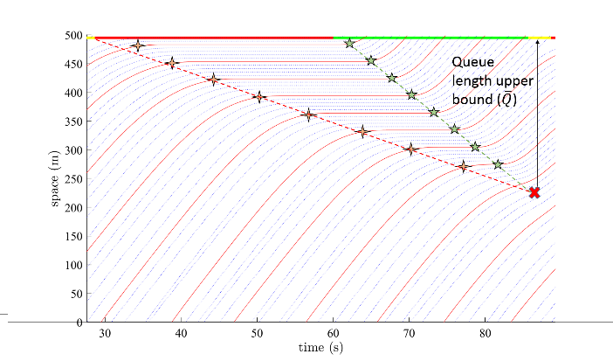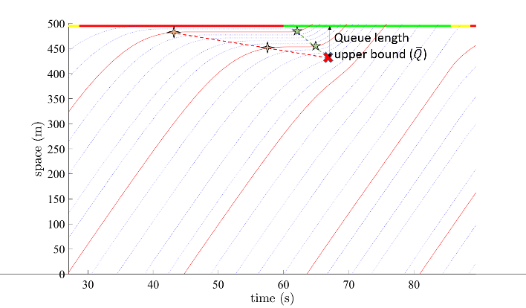

(a) (b)

Figure 3 An illustration to queue length upper bounds in a) high demand and b) low demand scenarios (source: FHWA).

1. If at least $τ^{sl}$ seconds has passed from when the signal turned green, estimate the free-flow traffic speed at the stop bar, denoted by $\overline{v}$. When the signal turns green, the vehicles in the queue accelerate to pass the intersection. Therefore, the traffic speed at the stop bar gradually increases to reach $\overline{v}$. The first $τ^{sl}$ seconds after the signal turns green can be considered as a transitional period, at which the traffic speed is still “slow”, thus in estimating $\overline{v}$, this time period is ignored. Figure 4 illustrates this transitional period. $\overline{v}$ is set to the average speed of the connected vehicles at the stop bar location during after the $τ^{sl}$ transitional time period and current time $t$.

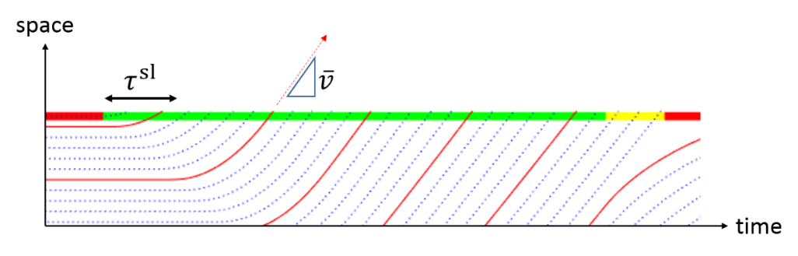

Figure 4 An illustration to the start-up lost time and free-flow speed at the stop bar (source: FHWA).

1. Estimate the time that is required for the queue to be discharged. Assuming that the queued vehicles can potentially move with the maximum speed of $\overline{v}$ after the signal turns green, one can estimate the time the queue would require to discharge from the intersection. Let $τ^{Q}$ denote the time period from the beginning of the signal red interval to the time when the queue would be discharged that is calculated as follows.
$$τ^{Q}≔\frac{\overline{Q}-α_{1}}{w_{1}}+\frac{\overline{Q}}{\overline{v}}$$

2. Record the time when the signal turns back to red. Let $τ^{R}$ denote the time period from the beginning of the last red interval to the beginning of the current red interval.
3. Detect the signal failure status. It can be shown that a signal cycle failure happens if $τ^{Q}>τ^{R}$. Otherwise, no cycle failure is recorded. Figure 5 illustrates $τ^{Q}$ and $τ^{R}$ estimation and cycle failure detection for two traffic scenarios: relatively high and low demand cases, as shown in Figure 5(a) and Figure 5(b), respectively.

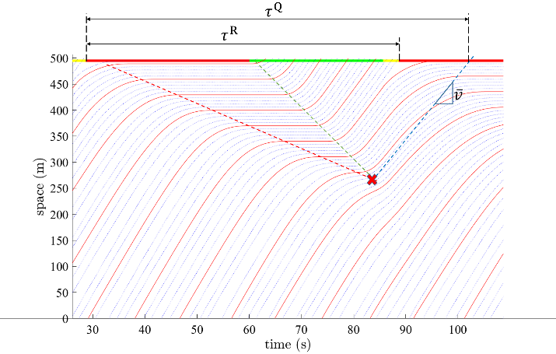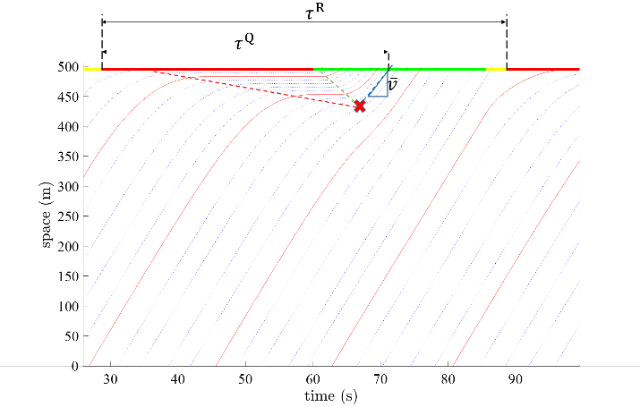

1. Cycle failure (b) No cycle failure

Figure 5 An illustration to the cycle failure status in a) high demand and b) low demand scenarios (source: FHWA).

## References

NCHRP. 2015. “Signal Timing Manual.” 812. Transportation Research Board.